JENKINS TASK-2
Task Description:
Create a simple script file and push it to repo. Create a project in Jenkins connected to your GitHub repository. When a commit is made to your repo, automatically build must get triggered from Jenkins and the output must be shared to me via email.
O/P:
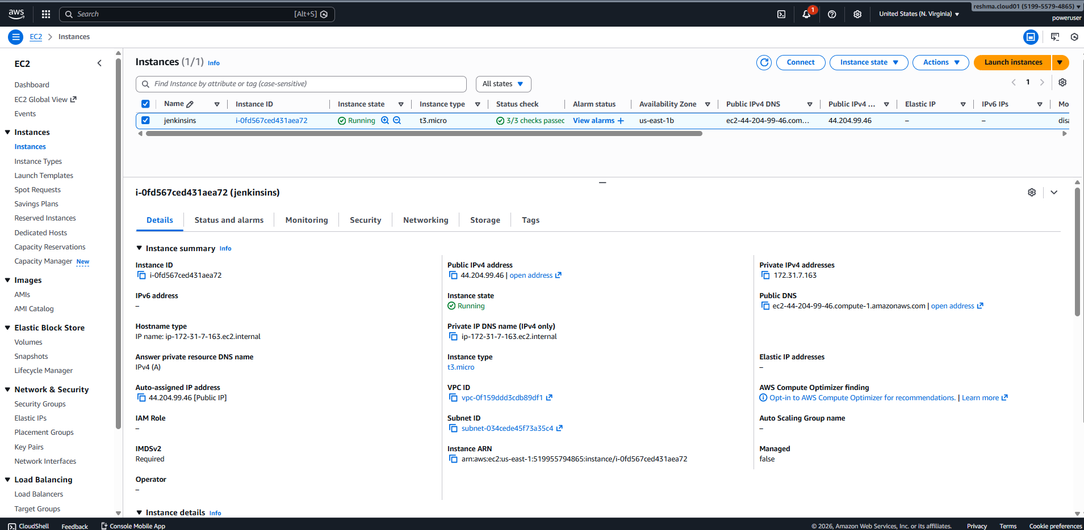
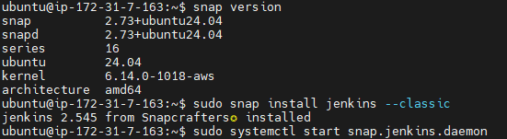
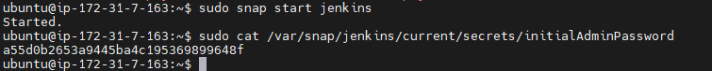
b) Create GitHub Repository:
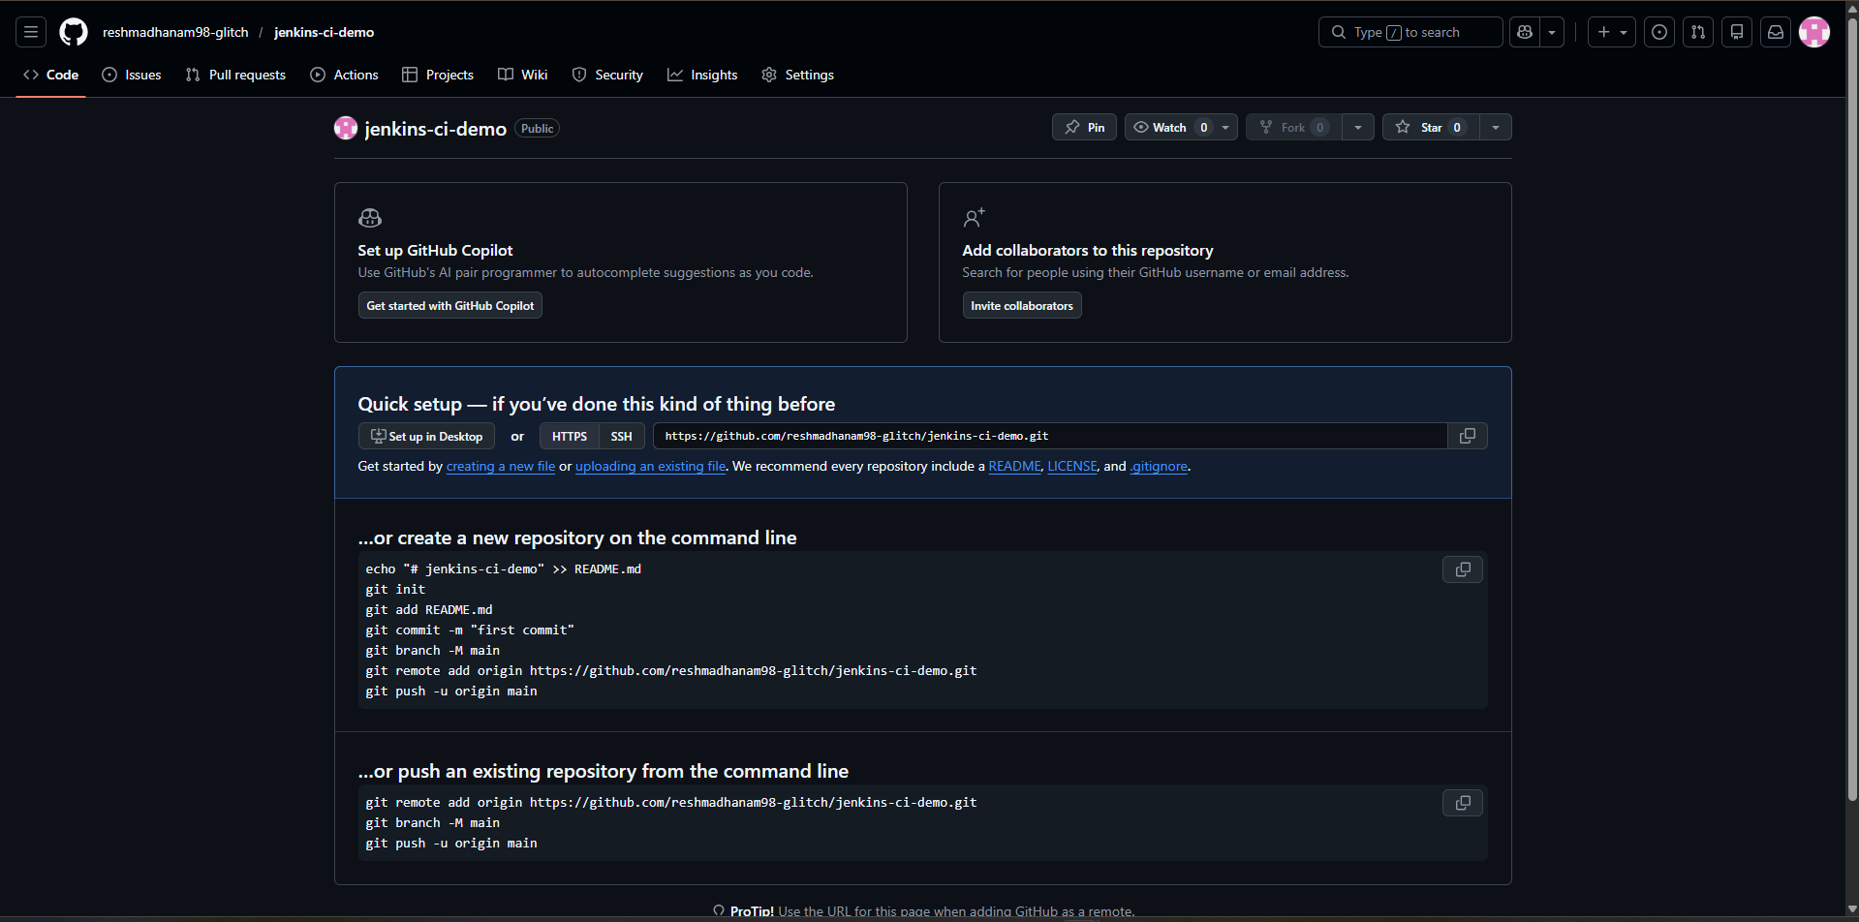
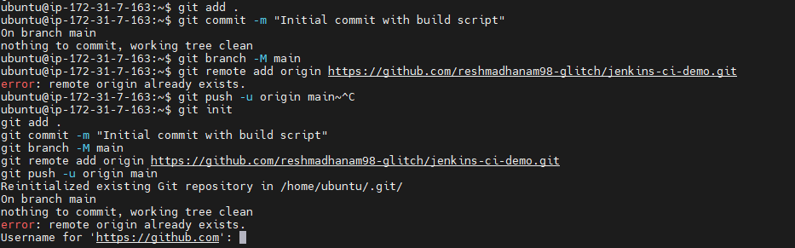
c) Configure GitHub Webhook (Auto Trigger):
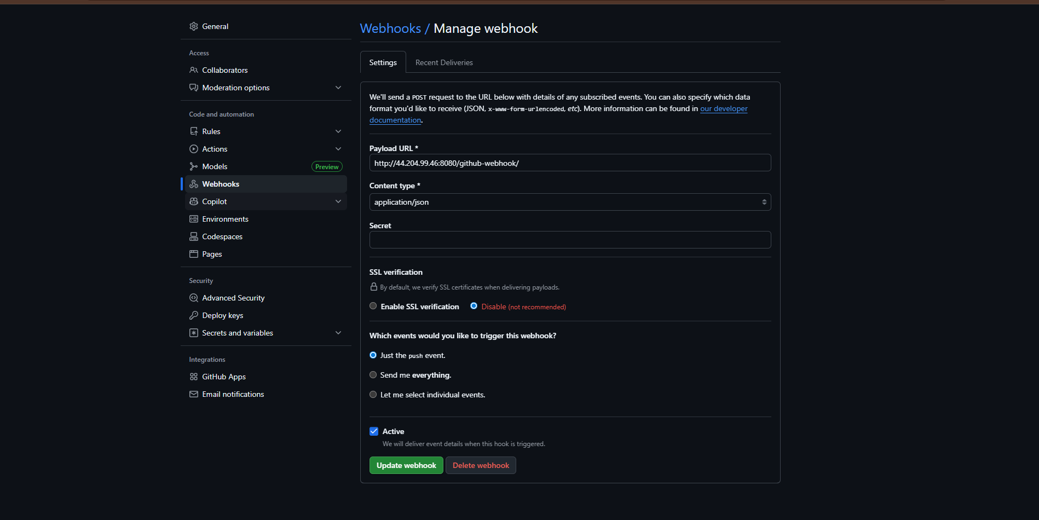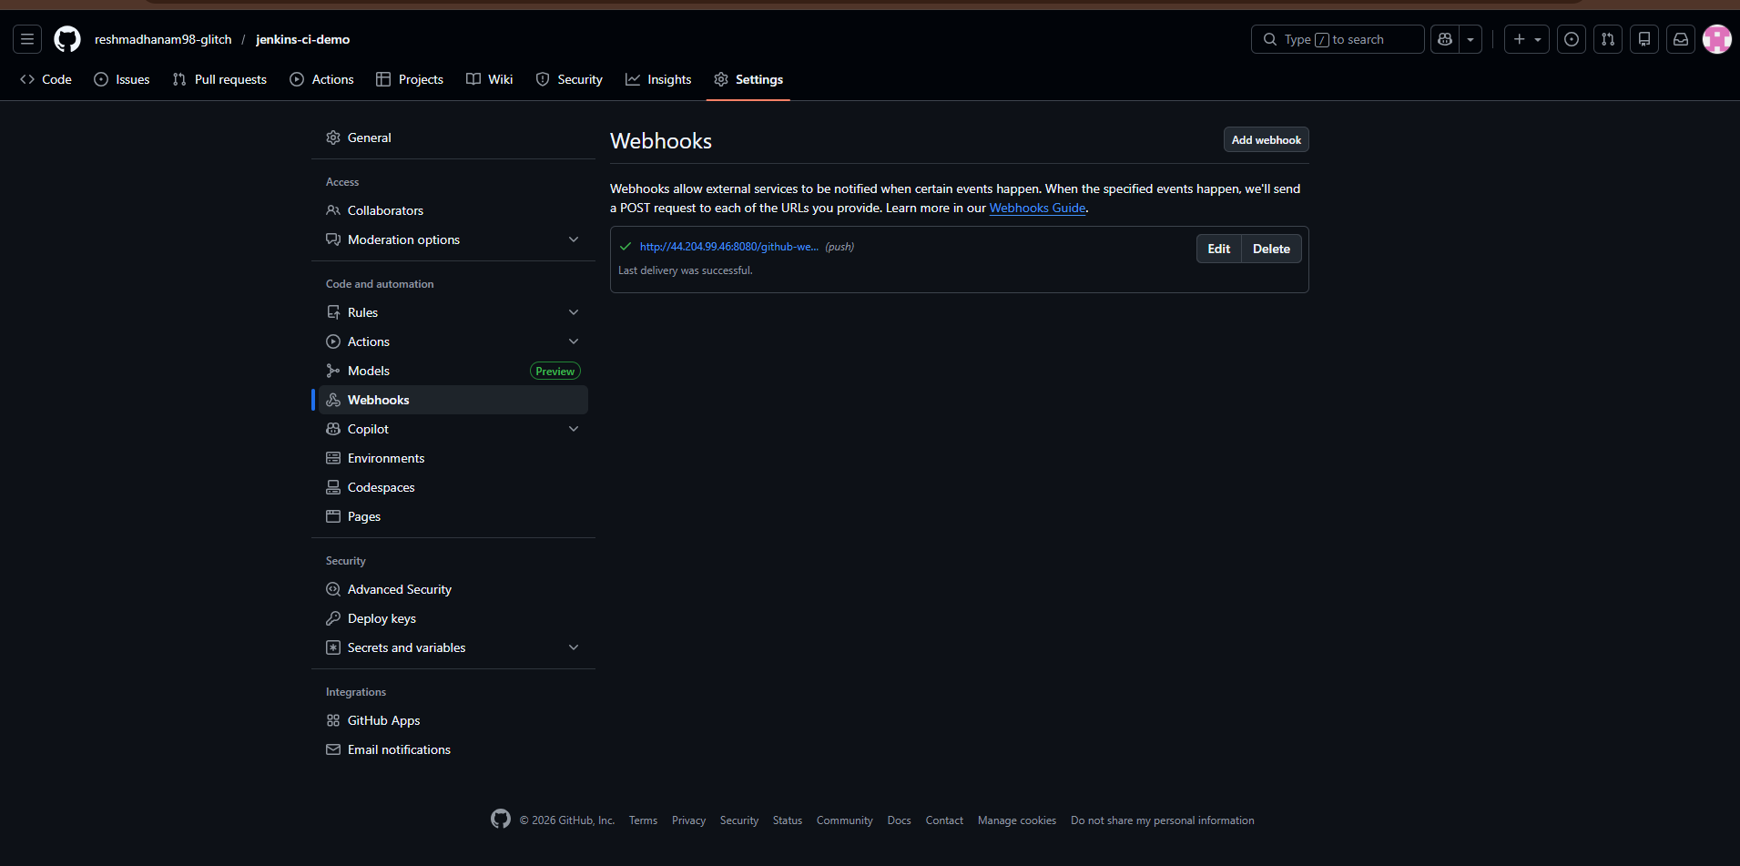
d) Create Jenkins Project:
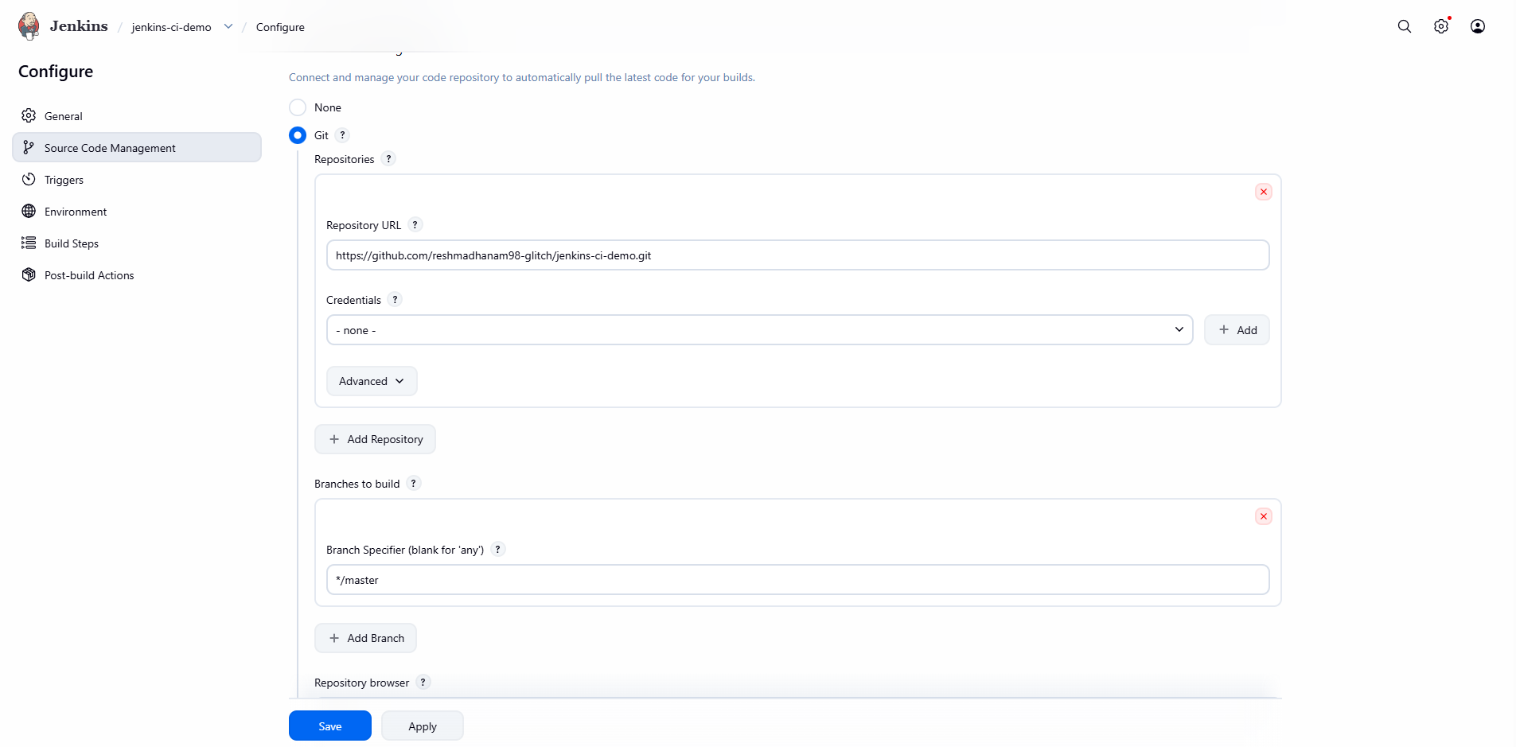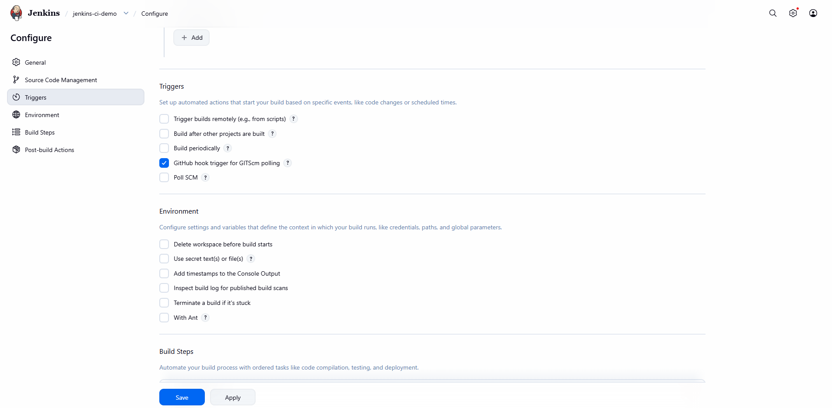
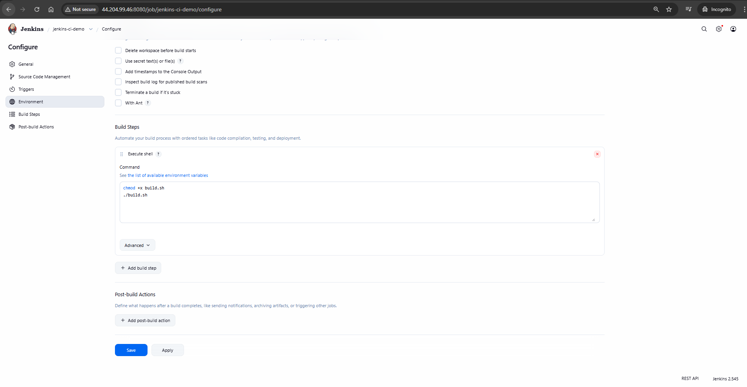
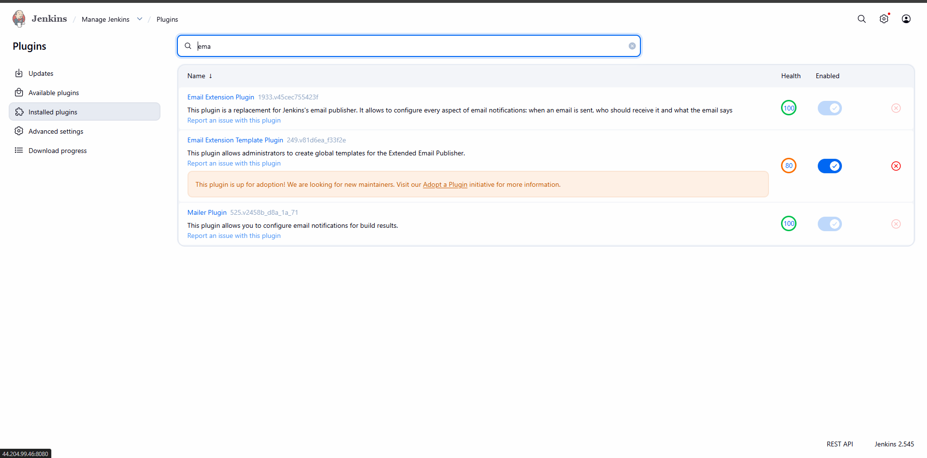
e) Configure Email Notification in Jenkins:

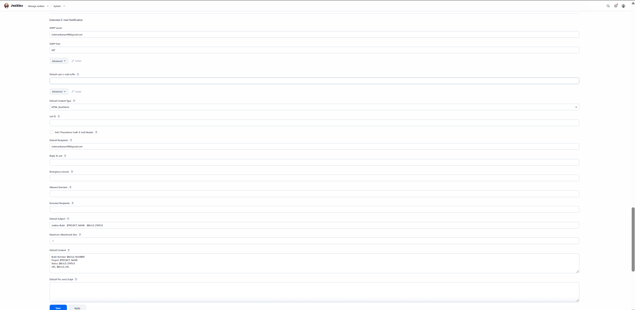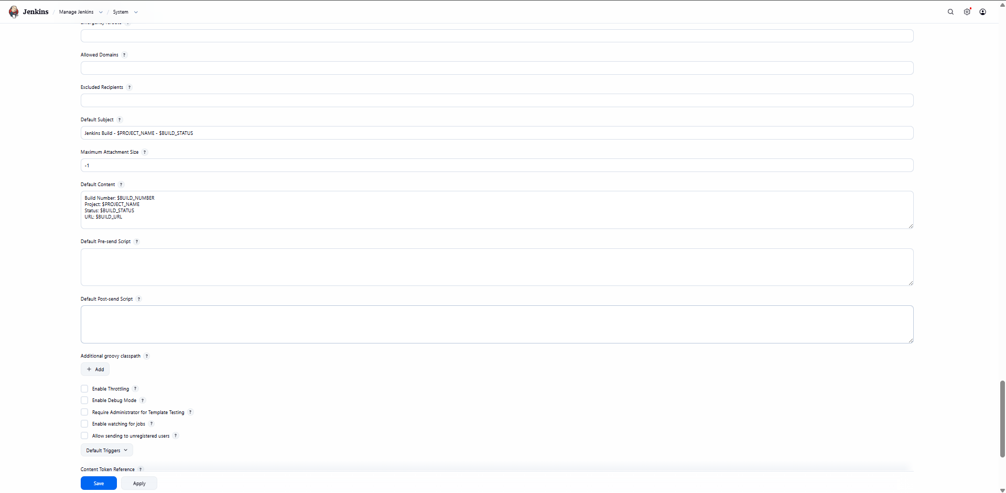
f) Add Email Notification to Job:
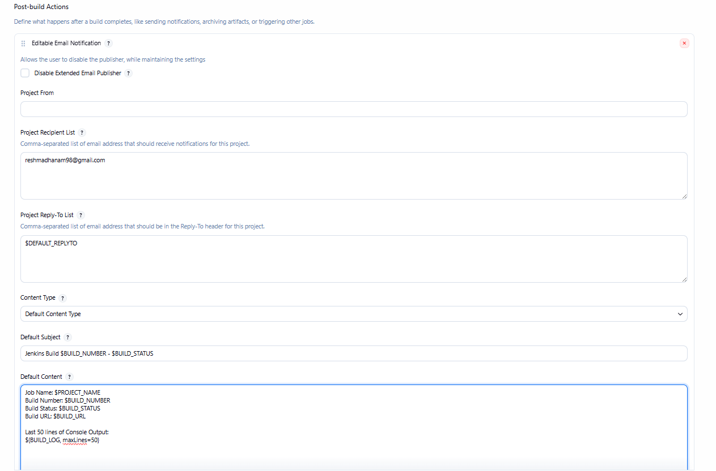
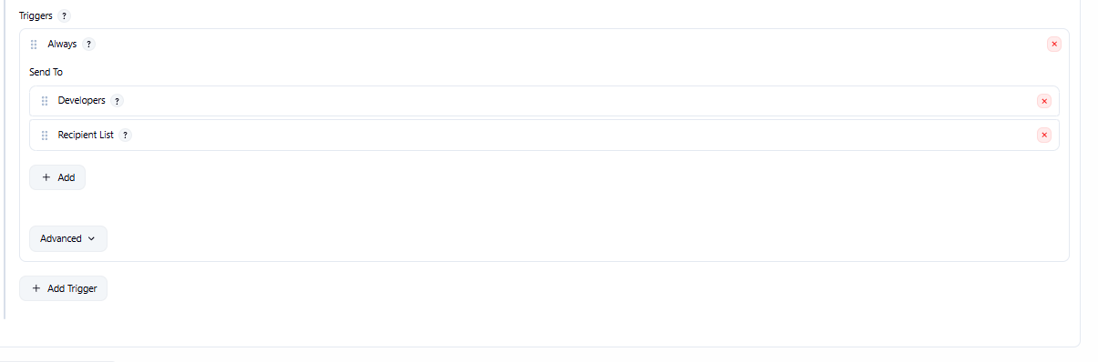
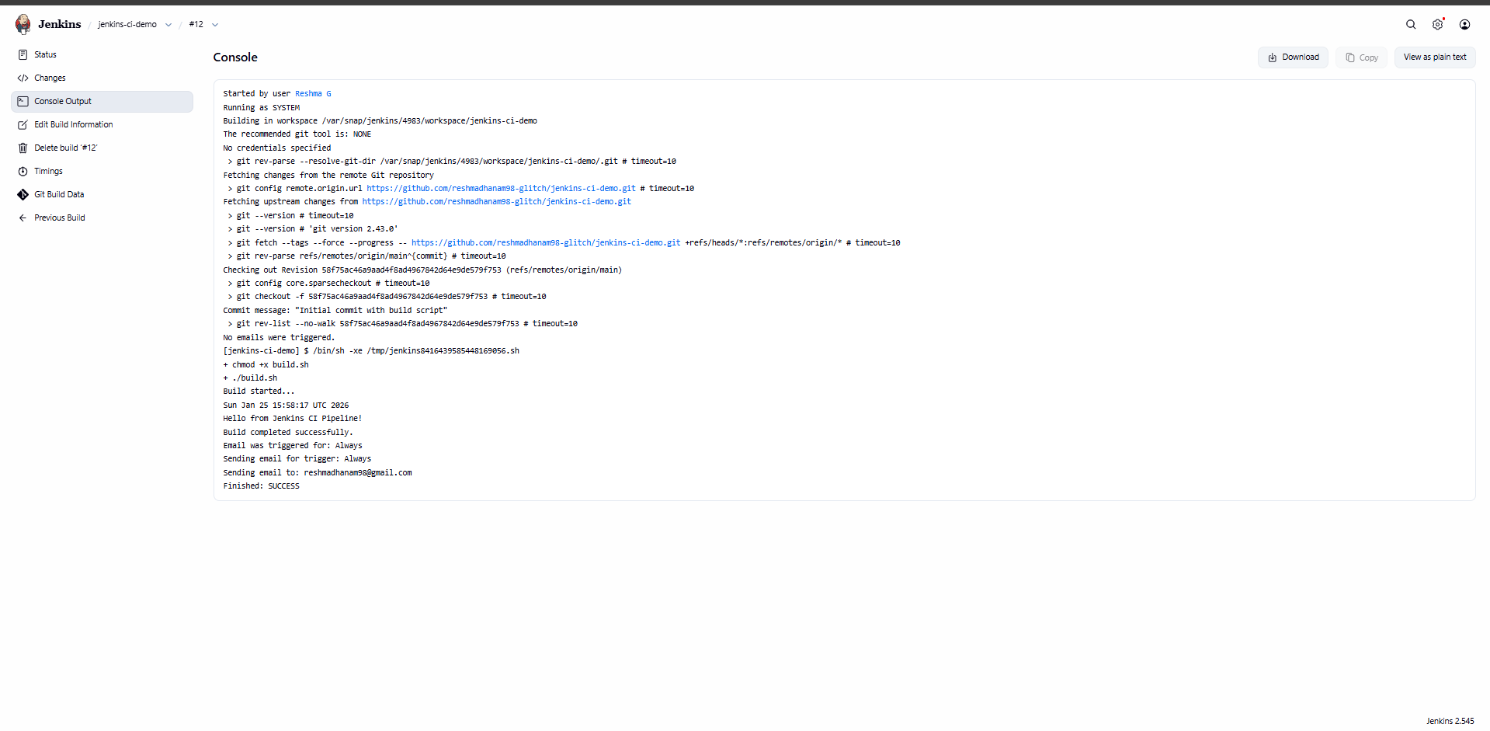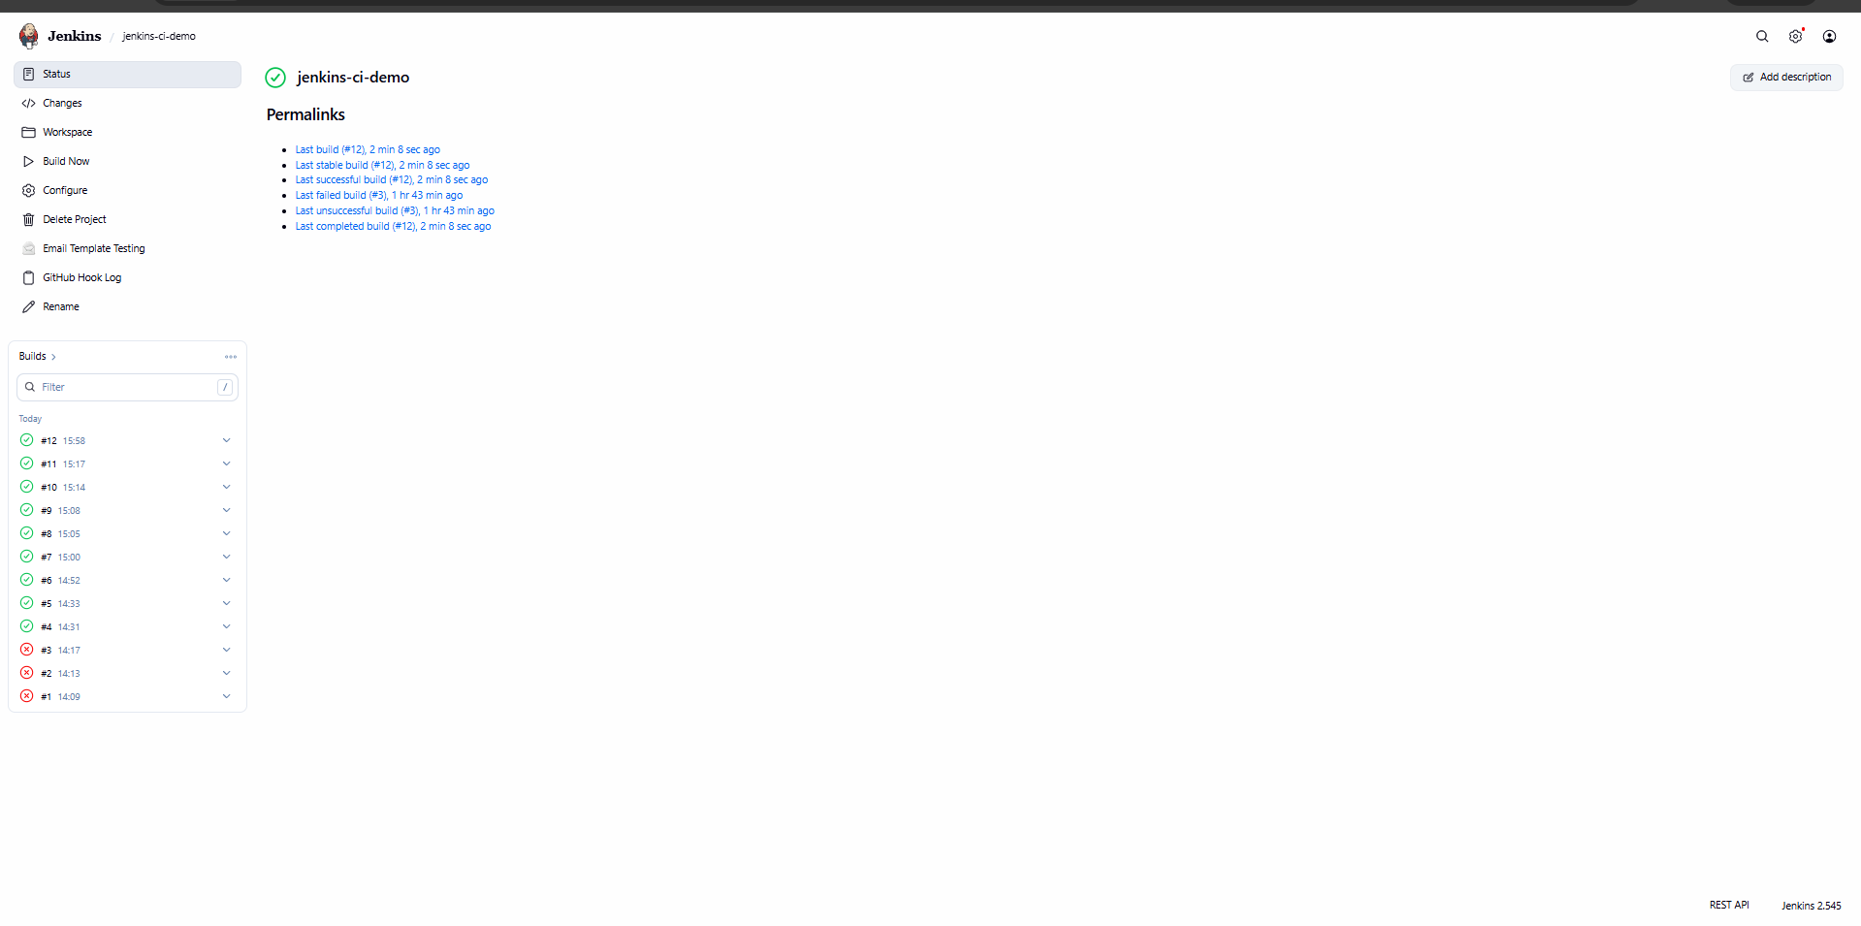

I DON’T HAVE SPECIFIC DOMAIN NAME(COSTING) TO RECEIVE THE EMAIL TO MY PERSONAL EMAIL ADDRESS

